Repository Setup
Objective: Clone the empty GitHub repository to the local machine
Command:
git clone git@github.com:Childish-kid75/devops-toolchain-milestone3.git
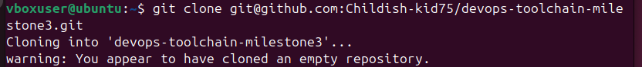
Figure 1: Successful repository clone (empty repository warning is expected)

Create Project Structure
Objective: Create initial project folders and files
Commands:
mkdir -p scripts docker chef website docs
echo "# DevOps Toolchain Project" > README.md
Initial commit:
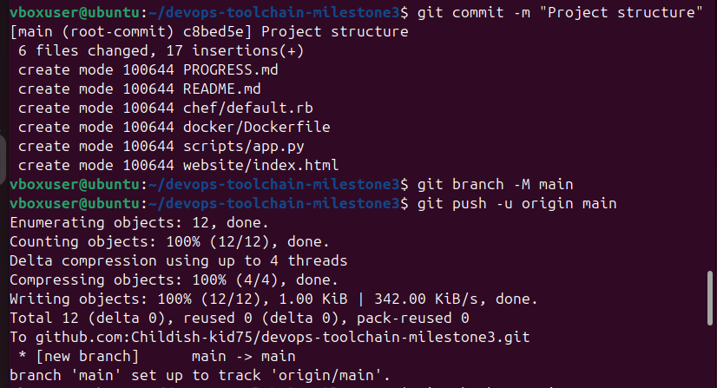
Figure 2: Initial project structure committed to main branch

Create Individual Folders
Objective: Create folders for all team members’ Part B exercises
Command:
mkdir -p individuals/{tshiamo,darius,ditheto,sizakele,nthailane,temosho,christiaan,reghardt,steven}/{docker,git,chef}
Output:
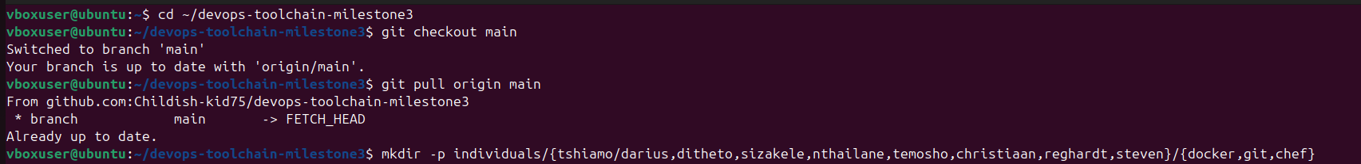
Figure 3: Individual folders created for all team members

Create Individual Branches
Objective: Create personal branches for each team member
Commands:
for name in tshiamo darius ditheto sizakele nthailane temosho christiaan reghardt steven; do
git checkout -b $name-partb
git push origin $name-partb
git checkout main
done
Output:
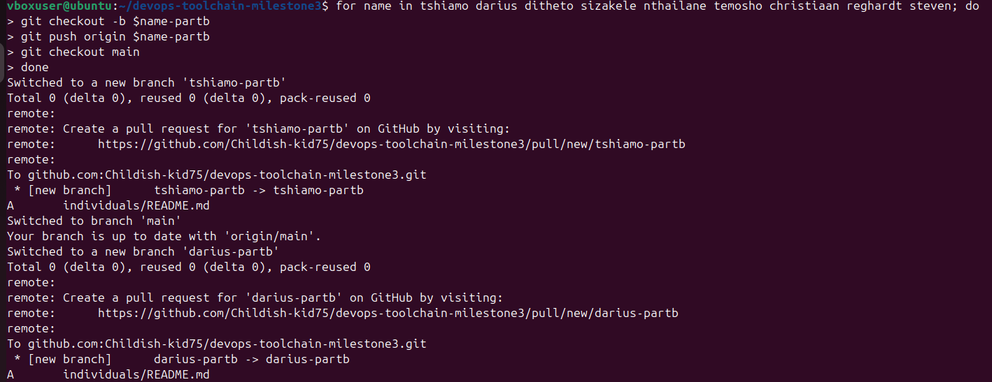
Figure 4: Personal branches created for all team members

Add Placeholder Files
Objective: Preserve directory structure in Git
Command:
find individuals -type d -exec touch {}/.gitkeep \;
git add .
git commit -m "Create individual folders and branches for Part B exercises"
Output:
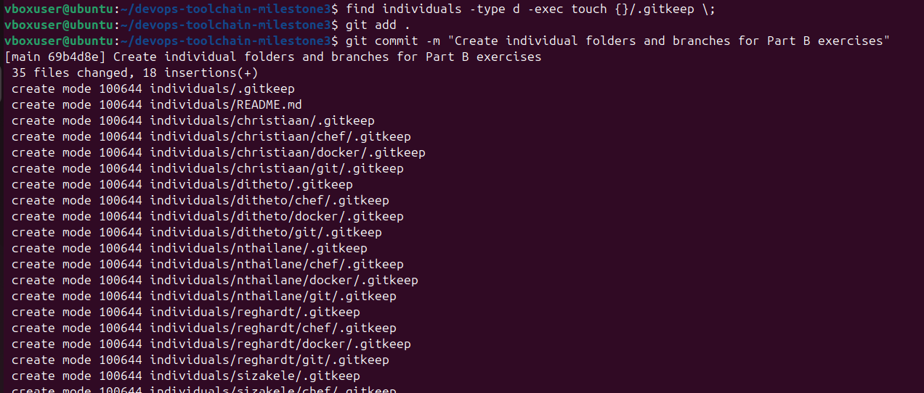
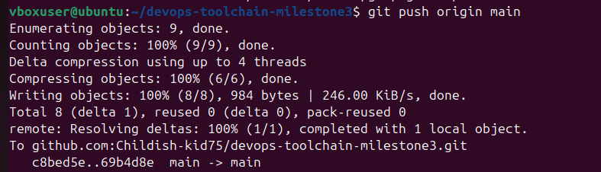
Figure 5: Placeholder files added and pushed to main branch

Verify Branches
Objective: Confirm all branches were created successfully
Command:
git branch -a
Output:
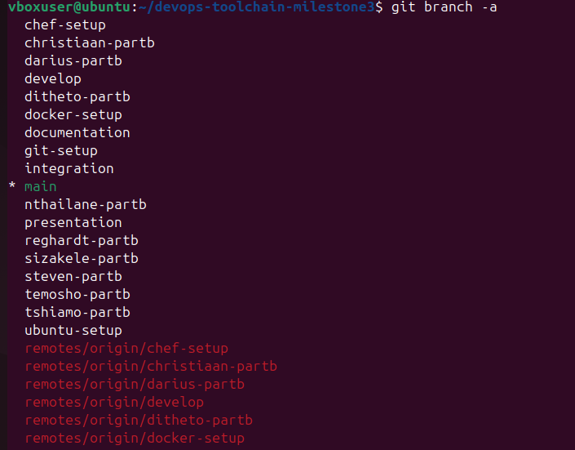
Figure 6: All team branches visible (chef-setup, docker-setup, and individual -partb branches)*

Docker Exercise
Objective: Create a Python script and Dockerfile
Files Created:
app.py:
print("=" * 50)
print("DevOps Practical Assignment")
print("Docker Container Running Successfully!")
print("Executed by: Tshiamo")
print("=" * 50)

Dockerfile:
FROM python:3.9-slim
WORKDIR /app
COPY app.py .
CMD ["python", "app.py"]
Output:
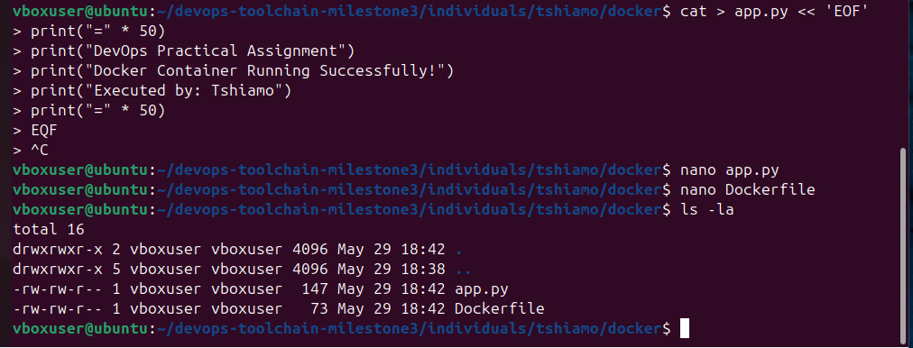
Figure 7: app.py and Dockerfile created successfully

Build Docker Image
Objective: Build a custom Docker image
Command:
docker build -t tshiamo-python-app .
Output:
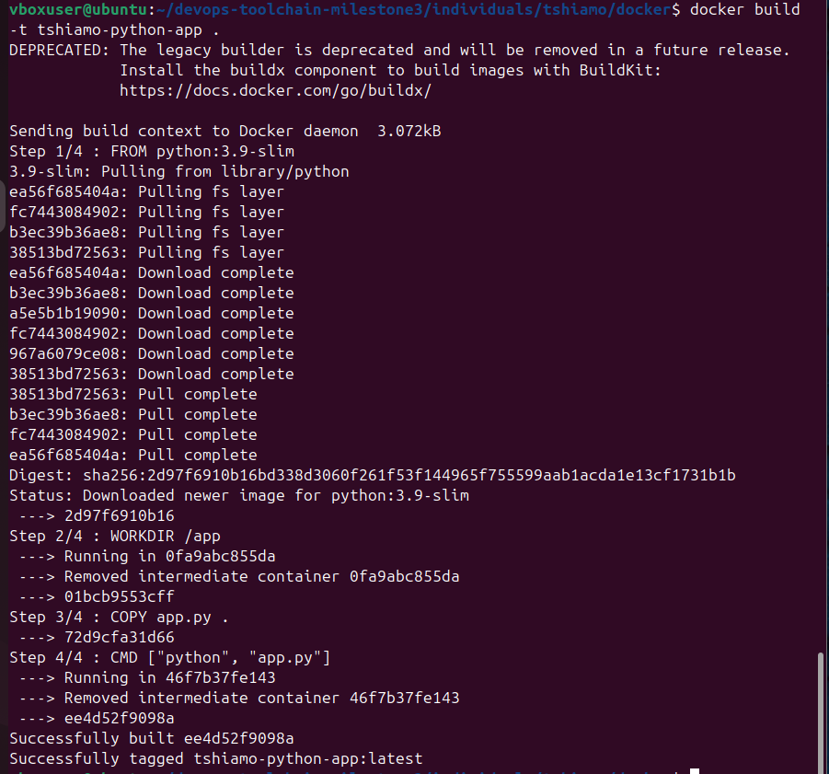
Figure 8: Docker image built successfully (python:3.9-slim pulled, layers cached)

Run Docker Container
Objective: Execute container and verify output
Command:
docker run tshiamo-python-app
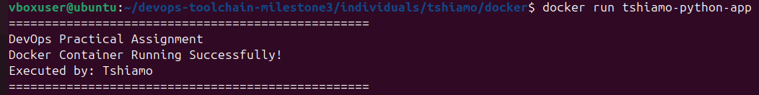
Figure 9: Container running successfully with expected output

Commit Docker Work
Objective: Save Docker exercise to GitHub
Command:
git add individuals/tshiamo/docker/
git commit -m "Complete Docker exercise - successfully built and ran container"
git push origin tshiamo-partb
Output:
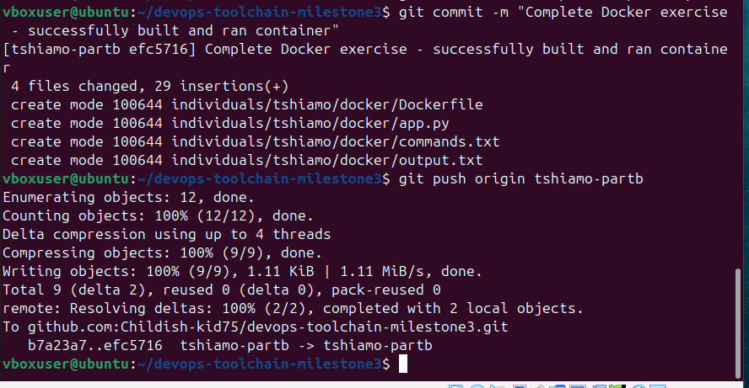
Figure 10: Docker exercise committed and pushed to tshiamo-partb branch

Git Exercise

Create Git Documentation
Objective: Demonstrate Git commands and workflow
Commands Documented:
git init
git add index.html
git commit -m "Initial commit"
git log --oneline
git status
Output:
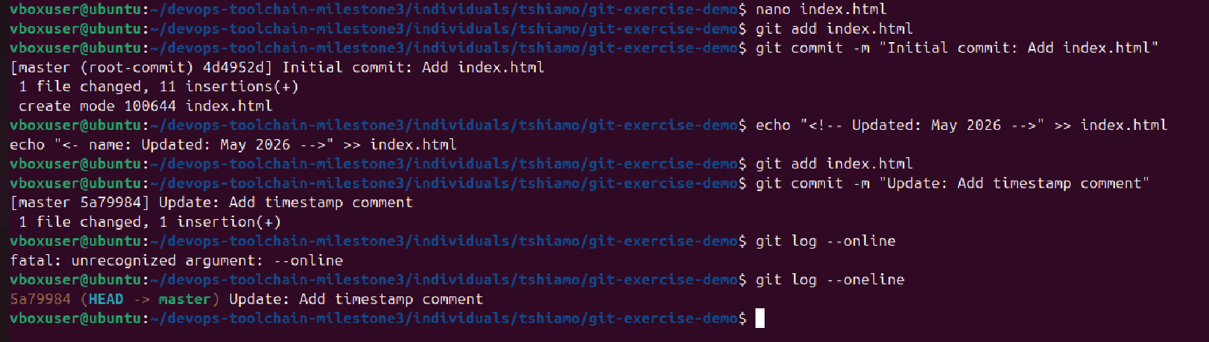
Figure 11: Git exercise documentation committed

Verify Git History
Objective: Show commit history
Command:
git log --oneline --graph –all
Output:
Figure 12: Git commit history showing all exercise commits

Chef Exercise

Generate Cookbook
Objective: Create Chef cookbook structure
Command:
chef generate cookbook nginx_cookbook
Output:
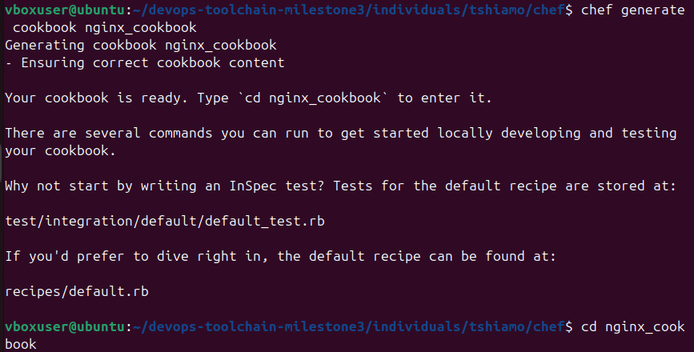
Figure 13: Chef cookbook generated successfully

Create Chef Recipe
Recipe Content (nginx-recipe.rb):
cd ~/devops-toolchain-milestone3/individuals/tshiamo/chef

# Create a standalone recipe file
cat > nginx-recipe.rb << 'EOF'
# Install Nginx
package 'nginx' do
action :install
end

# Start and enable Nginx service
service 'nginx' do
action [:enable, :start]
end

# Create custom index.html
file '/var/www/html/index.html' do
content '
<!DOCTYPE html>
<html>
<head>
<title>Tshiamo - Chef Exercise</title>
</head>
<body>
<h1>DevOps Practical Assignment</h1>
<h2>Chef Configured Nginx</h2>
<p>Successfully configured by: Tshiamo</p>
<p>Date: May 2026</p>
<hr>
<p>This web server was installed using Chef.</p>
</body>
</html>
'
mode '0644'
action :create
end
EOF

# Apply the recipe directly
sudo chef-apply nginx-recipe.rb

Apply Chef Recipe
Objective: Run chef-apply to configure Nginx
Command:
sudo chef-apply nginx-recipe.rb
Output:
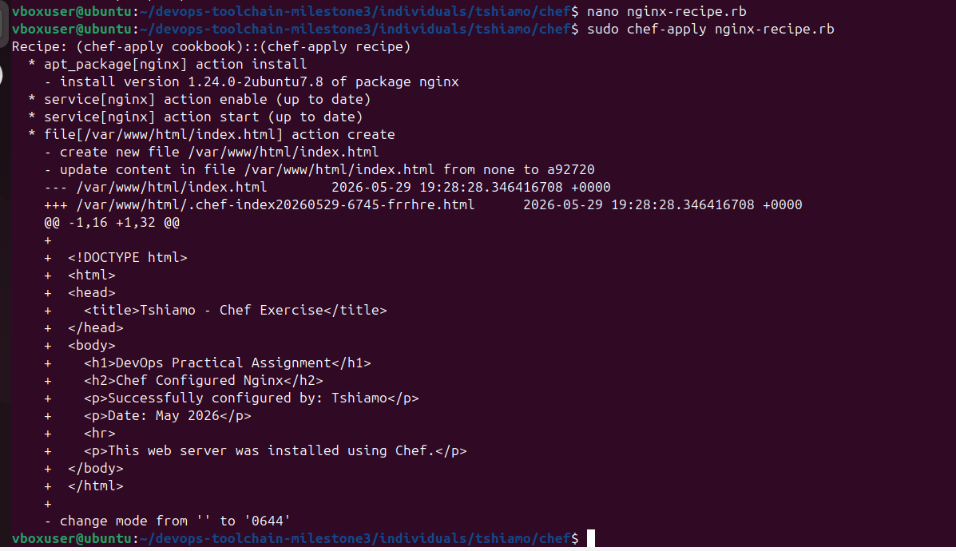
Figure 14: Chef-apply successfully installed Nginx and created custom webpage

Verify Nginx Webpage
Objective: Confirm webpage is accessible
Command:
curl http://localhost
Output:
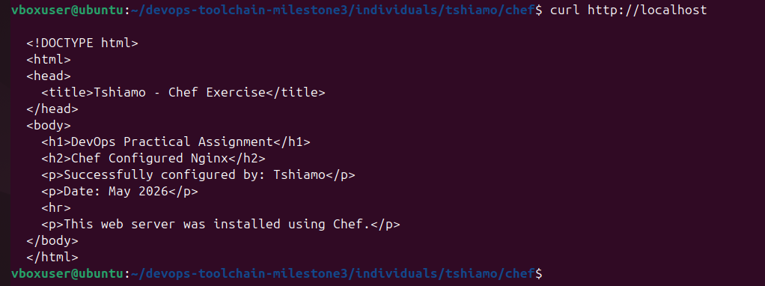
Figure 15: Custom webpage successfully served by Nginx

Final GitHub Status

All Commits Pushed
Objective: Verify all Part B exercises are on GitHub
Commits on tshiamo-partb branch:
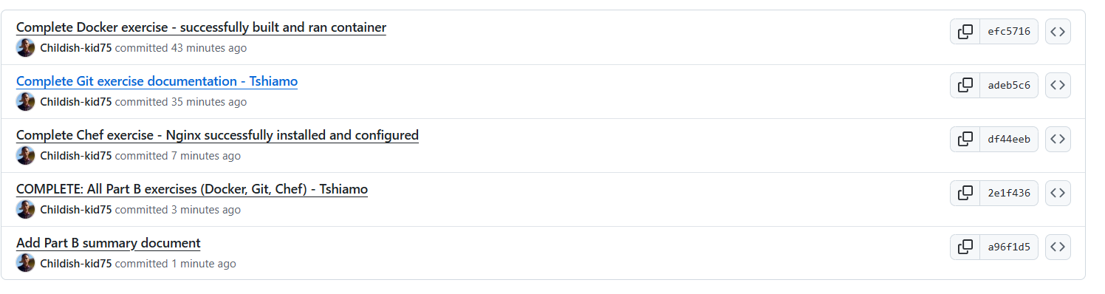
Figure 16: Complete commit history showing all three exercises
Commits:
- efc5716 - Complete Docker exercise
- adeb5c6 - Complete Git exercise documentation
- df44eeb - Complete Chef exercise
- 2e1f436 - COMPLETE: All Part B exercises
- a96f1d5 - Add Part B summary document

GitHub Branch Overview
Objective: Show branch structure on GitHub
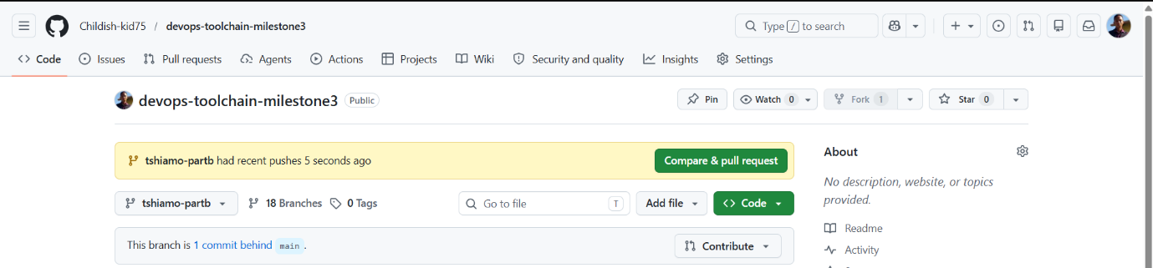
Figure 17: GitHub repository showing tshiamo-partb branch and recent pushes

